A+ Computer Science IFS – Flower Maze Lab Value - 100

Lab Goal: To figure out the most efficient ways of solving a problem. Although seeming simple, one has to realize that not all methods will work.
Lab Description: This lab requires you to use a wide variety of if commands. The Jeroo must pick up the flowers to break the nets, completing the maze. This lab requires a multitude of methods. Although possible, it is very difficult to solve by using loops.
Files Needed:
JerooFlowerMaze.jsc
JerooFlowerMaze.jev

Starting Screen:
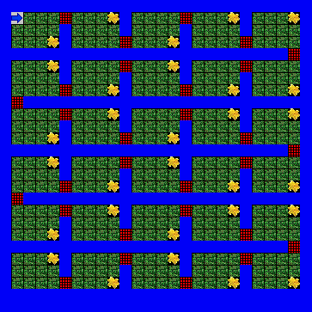
algorithm help

Required Conditionals
- Must use at least 1 method other than main
Postcondition –
- All flowers must be picked and all nets must be broken
- The Jeroo cannot go in the water
- Must end while facing south

Ending Screen:
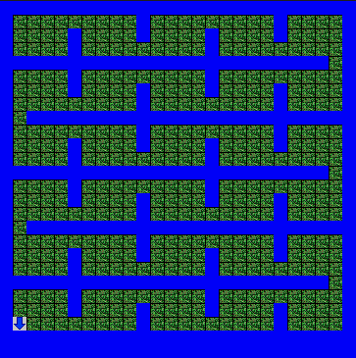

BONUS: Use Loops

